Functional Specifications Document

Automated Facial Recognition Attendance System

Project Code:
AFAS-2024

Internal Advisor:
Mr. Farooq Javeed

Project Manager:
Dr. Muhammad Ilyas

Project Team:
Muhammad Zakaria Masood (Team Lead)
Zill E Haseeb (Member)

Submission Date:
December 25, 2023

_____________________

Project Manager’s Signature

Document Information

Category | Information
Customer | SU
Project | Automated Facial Recognition Attendance System
Document | Requirement Specifications
Document Version | 1.0
Identifier | Sweet_Stalker_AFAS-2024
Status | Draft
Author(s) | Muhammad Zakaria Masood  Zill E Haseeb
Approver(s) | PM
Issue Date | Nov. 10, 2023
Document Location
Distribution | - Advisor  - PM  - Project Office

Definition of Terms, Acronyms and Abbreviations
This section should provide the definitions of all terms, acronyms, and abbreviations required to interpret the terms used in the document properly.

Term | Description
ASP | Active Server Pages
FSD | Functional Requirements Documents
DBMS | Database Management System

Table of Contents

1. Introduction 5
1.1 Purpose of Document 5
1.2 Project Overview 5
1.3 Scope 5
2. Functional Requirements 6
3. Non-functional Requirements 6
Non-functional requirements are system attributes, they constraints or restriction on the design of system and ensure the usability and effectiveness of the entire system. 6
3.1 Performance Requirements 6
3.2 Safety Requirements 6
3.3 Security Requirements 6
3.4 User Documentation 7
4. Assumptions and Dependencies 7
5. System Architecture 7
6. Use Cases 8
6.1 Use Case Diagrams 8
1) System Use Case Diagram 8
6.2 Use Case Description 8
7. High Level Design 11
7.1 ER Diagram 11
8. Requirements Traceability Matrix 12

Introduction
This software requirements specification (SRS) document aims to provide guidelines and specifications for the design and development of an artificial intelligence (AI)-based attendance system that makes use of face recognition technology.

  - Purpose of Document
This FSD document serves to specify functional specifications for the AI-based attendance system. It intends to give a clear picture of the features, capabilities, and limitations of the system in order to direct development and guarantee alignment with project objectives.

  - Project Overview
The AI-based attendance system is an application of software that makes use of face recognition technology to completely transform attendance tracking. It will be utilized for precise and effective tracking in business and educational organizations. In addition to offering a use-friendly interface for people to register their facial biometrics, the system will evaluate real-time facial photos using deep learning algorithms and compare them with profiles that have already been pre-enrolled.
Administrators will be able to access and recover correct records due to the system’s safe storage and management of attendance data. The project’s objectives are to increase accuracy and dependability, reduce human effort, and automate the process. Benefits include less mistake, more efficient attendance management, better analytical and reporting capabilities, and better administrative decision-making. Real-time tracking of attendance records will be made possible by the AI-based attendance system, guaranteeing precise information for compliance reporting, performance reviews, and payroll processing.

  - Scope
The scope of the project includes the following:
- Functional Scope: The system will include functionalities such as facial biometric enrollment, real-time recognition, attendance data management, reporting and analysis. User will be able to register their facial biometrics easily, and the system will perform facial recognition for attendance tracking. Data will be securely stored and managed, comprehensive reports and analytics will be generated for administrators.
- Non-functional Scope: The system will prioritize performance, ensuring the ability to handle a large number of users and process facial recognition request in real-time. Security measures will be implemented to protect sensitive attendance data, including encryption, access control, and compliance with data privacy regulation. The system will feature a user-friendly interface for users to enroll their facial biometrics and access attendance records. Compatibility with commonly used hardware and software platforms will be ensured for seamless integration.

Functional Requirements
Functional requirements outline What the system should do and support user activities in performing and completing tasks by using the proposed system, The list below shows the functional requirements of this project.
- The system shall allow new users to register and use the platform
- The system allows the user to log in by using username and password
- The system will encrypt the user passwords
- The system will be able to detect a human face from an image
- The system will be able to recognize faces based on existing data
- The system must be able to identify the students and mark them as attended
- The system must be able to update the attendance database based on attended students
- The system will only take attendance of the class based on when activated to do so
- The system will generate report of students from database.

Non-functional Requirements
Non-functional requirements are system attributes, they constraints or restriction on the design of system and ensure the usability and effectiveness of the entire system.

  - Performance Requirements
- The system could be able to detect multiple faces at same time.
- The system will be available all day and perform processing efficiently.
- The system will create log to maintain the performance.

  - Safety Requirements
To prevent the system loss, protected actions will be implemented. To obtain data security, regular backups and secure storage are essentials. In case of an emergency or system failure, the system should include backup attendance marking mechanisms or emergency plans.

  - Security Requirements
To maintain the security of the system, data will be secure as encrypted like images because they are quite sensitive student’s data. User authentication and authorization will be maintained as user will be login with credentials and session will maintain that will be expire after some idleness.

  - User Documentation
User documentation helps users understand and effectively use the system. User manuals are comprehensive guidelines for system installation, configuration, and use, that will explain the system's features, workflows, and any necessary steps to perform various tasks.

Assumptions and Dependencies
The success of the project is dependent on its ability to satisfy the objectives, which include hardware and network resources, training and testing data, and user collaboration. The project is dependent on a number of assumptions, including the availability of required infrastructure, data, a stable operating environment, user collaboration, external component integration, and third-party services.

System Architecture
Architecture of our system is based on streaming capable cameras, application server, database server and end devices to operate this system.
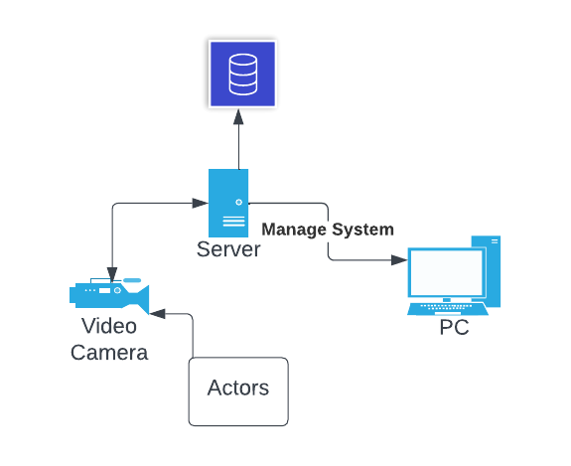
Figure 1: System Architecture

- Cameras: Cams will be responsible to manage facial recognition tasks by live streaming and comparing with existing data in database using edge computing. They capture the facial biometrics and mark attendance of actors.
- Database servers: Database servers will be used to manage database and purpose for managing data according to business constraints.
- Application Server: Applications servers will provide central processing to handle different tasks like add, update or delete data from the system
- End-devices: Admin members use end devices to operate system

Use Cases
The use case diagram represents a description of the main components of the system as well as its features and functionalities. In such diagram, we find the use cases, actors, the system and associations between them. In Automated Facial Recognition Attendance System, there is only one actor, administrator interacting with the system.

  - Use Case Diagrams
- System Use Case Diagram
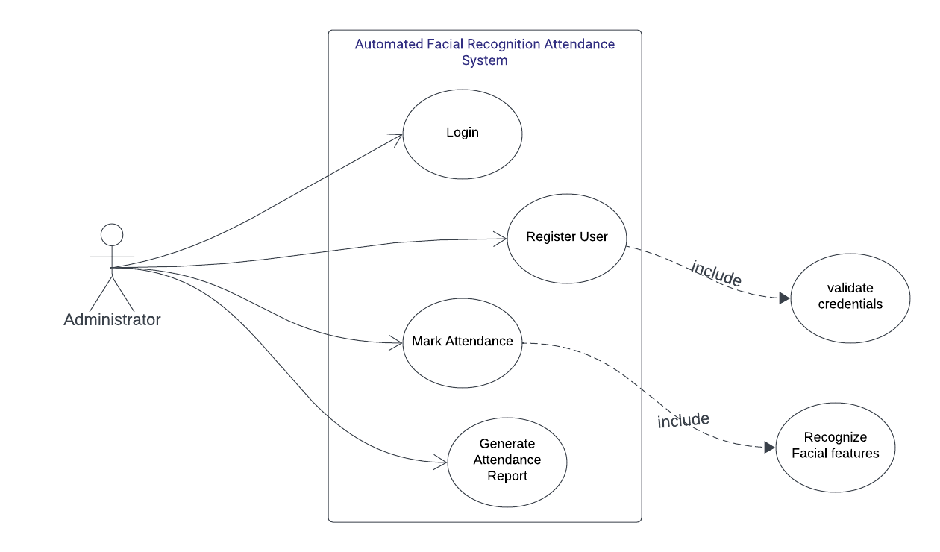
Figure 2: Use Case Diagram
Description: The use case diagram shows the role of administrator interacting with the system as they can manage the system functionalities by registering students and faculty in the system, monitor attendance and generate a report from the system that will be captured by video cameras.

  - Use Case Description

U1: Login
Actors: Administrators
Feature: Login
Use case Id: |  | U1
Pre-condition: |  | You must have a PC installed with AFRAS software
Scenarios
Step# | Action |  |  | Software Reaction
1. | Open Sign in page |  |  | Render Sign in Page
2. | Put Credentials |  |  | Verify and validate credentials
3. | Trigger Log in |  |  | Show the home screen
Alternate Scenarios:
1a: wrong credentials

2a:

Post Conditions
Step# | Description
01 | Register Actors
02 | Manage Attendance
03 | Generate Report
Use Case Cross referenced |  |  | Administrators
User Interface reference |  |  | - Login Page  - Home Screen
Concurrency and Response
Give an estimate of the following
◻ Actors: Multiple Administrators
◻ Response Time: Less than 500ms.

U2: Registration
Actors: Administrators
Feature: Register Other actors, like students and faculty
Use case Id: |  | U2
Pre-condition: |  | Admin should be logged in
Scenarios
Step# | Action |  |  | Software Reaction
1. | Register Students and Faculty |  |  | Update database
2. | Delete Actors |  |  | Update Database
Alternate Scenarios:
1a: Update Actors data

2a:

Post Conditions
Step# | Description
01 | Students and Faculty will be added in system database
Use Case Cross referenced |  |  | Administrators
User Interface reference |  |  | - Home screen  - Attendance Sheet
Concurrency and Response
Give an estimate of the following
◻ Actors: Multiple Administrators
◻ Response Time: Less than 500ms.

U3: Mark Attendance
Actors: Administrators
Feature: Login
Use case Id: |  | U3
Pre-condition: |  | Students and faculty must be registered in the system
Scenarios
Step# | Action |  |  | Software Reaction
1. | Update mark sheet |  |  | Update database
Alternate Scenarios:
1a: System Errors

2a:

Post Conditions
Step# | Description
01
Use Case Cross referenced |  |  | Administrators
User Interface reference |  |  | - Attendance sheet
Concurrency and Response
Give an estimate of the following
◻ Actors: Multiple Administrators
◻ Response Time: Less than 500ms.

U4: Report
Actors: Administrators
Feature: Login
Use case Id: |  | U4
Pre-condition: |  | Database has been configured with business constraints
Scenarios
Step# | Action |  |  | Software Reaction
1. | Report regarding attendance wrt class |  |  | Update database
Alternate Scenarios:
1a:

2a:

Post Conditions
Step# | Description
01 | Periodically report will be generated in database
Use Case Cross referenced |  |  | Administrators
User Interface reference |  |  | - Reports Page
Concurrency and Response
Give an estimate of the following
◻ Actors: Multiple Administrators
◻ Response Time: Less than 500ms.

High Level Design

  - ER Diagram
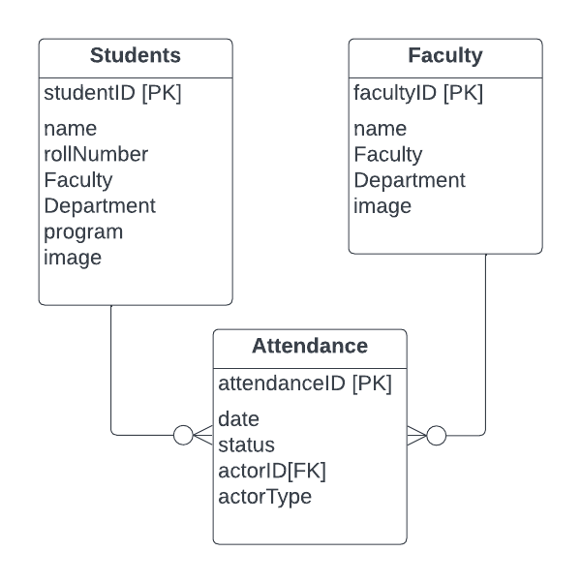
Figure 3: ER Diagram

Requirements Traceability Matrix

Sr. | Feature | Use case ID | UI ID | Priority | Build Number | Use Case Cross reference  (Related Use Cases)
01 | Login | U1 | UI1 | 4/5 | 1 | Administrators
02 | Registration | U2 | UI2 | 4.8/5 | 2 | Administrators
03 | Attendance | U3 | UI3 | 4/5 | 3 | Administrators
04 | Report | U4 | UI4 | 4.8/5 | 4 | Administrators

